Summary of monthly reports on Zionist attacks on the city of Al-Quds and the Al-Aqsa Al-Mubarak Mosque

Summary of the monthly report for the month of March, 2021.
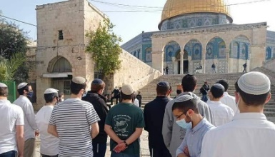
- The number of settlers who stormed Al-Aqsa Mosque during March was around 2,650 Zionists.
- In March, the occupation government demolished 34 houses and facilities.
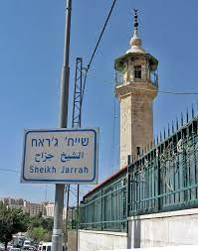
- Two Al-Quds neighborhoods and a village in Al-Quds are currently under threat of demolition; They are Sheikh Jarrah neighborhood, north of the Old City, and Bustan neighborhood to the south, and the isolated walled village of Al-Jib, northwest of occupied Al-Quds.
- More than 130 arrests of Jerusalemite figures, males and females, were recorded including mosque custodians, youths, seniors, sheikhs and intellectuals of the city of Al-Quds.
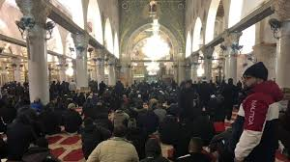
- In March, the occupation government approved 3 amendments to expand the settlement of "Pisgat Ze'ev.". The "Planning and Construction Committee" in the occupation municipality revealed that the project included the construction of around 930 new settlement units in the abovementioned settlement that was established on lands confiscated from the towns of Beit Hanina and Anata, at a cost of 350 million shekels (about US $ 110 million).
- The people of Al-Quds have revived the "Great Fajr" initiative in large numbers.
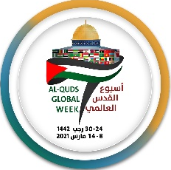
- The initiative (International Al-Quds Week) was launched from March 6 to March 12, 2021.

